2B Displaying Single Data Sets – Lesson 6
Statistics – Range and IQR with Stem-and-leaf plot.

Name: _________________
- What is a stem-and-leaf plot?

- Use the following stem-and-leaf plot.

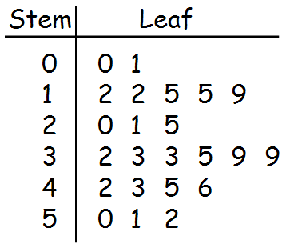
  - Circle the median. What was it?

  - Circle Q1. What was it?

  - Circle Q3. What was it?

  - Calculate the Interquartile Range. [IQR = Q3 – Q1]

  - Calculate the Range [Highest score minus lowest score].

- Use the following stem-and-leaf plot.
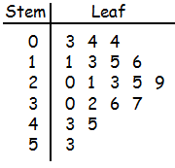
  - Circle the median. What was it?

  - Circle Q1. What was it?

  - Circle Q3. What was it?

  - Calculate the Interquartile Range. [IQR = Q3 – Q1]

  - Calculate the Range [Highest score minus lowest score].

